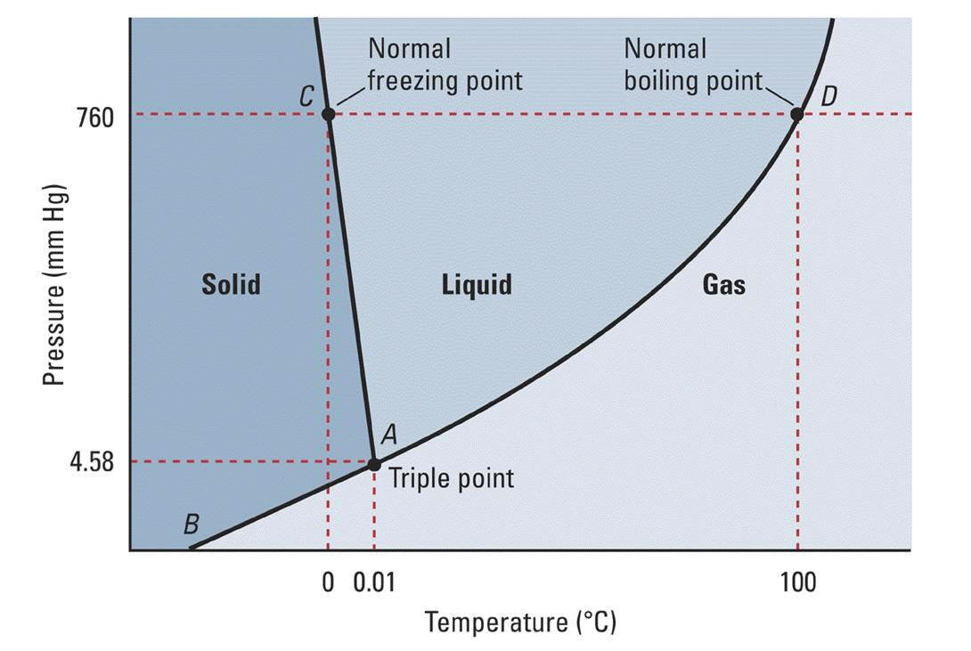
Phase Diagram of Water Worksheet

1. a. This is a phase diagram for what compound?

b. What is the formula for this compound?

2. Name the x-axis and y-axis in the phase diagram.

3. In what units are these two variables measured on the phase diagram?

4. Name the three states of matter separated by solid lines on the phase diagram.

5. Trace over the solid line separating Solid / Gas in red. Trace over the solid line separating Liquid / Gas in blue and trace over the solid line separating Solid / Liquid in green.
6. The process (change of state) of condensation occurs when a gas changes into a liquid. Draw and label a blue arrow going across the solid line showing the direction of condensation. The process of boiling occurs when a liquid changes into a gas. Draw and label a blue arrow across the solid line showing the direction of evaporation.
7. The process of freezing occurs when a liquid changes into a solid and the reverse process is melting. Draw and label green arrows showing these two phase changes.
8. The process of deposition occurs when a gas changes into solid and the reverse process is sublimation. Draw and label red arrows showing these two phase changes.
9. Circle on the phase diagram where the three solid lines meet. What is this junction called?
10. Use the phase diagram to determine what state of matter H₂O is at -10C and 700 mm Hg.

10. Use the phase diagram to determine what state of matter H₂O is at 50C and 750 mm Hg.

11. Use the phase diagram to determine what state of matter H₂O is at 150C and 50 mm Hg.

12. At a constant 760 mm Hg, list all the states of matter and processes (changes of state) that H₂O undergoes when heated
from -10C to 110C.

13. At a constant 2 mm Hg, list all the states of matter and processes that H₂O undergoes when cooled from
50C to -50C.

14. At a constant -10C, list all the states of matter and processes that H₂O undergoes when depressurized
from 5 mm Hg to 0 mm Hg.

15. At 0C, explain all the states of matter and processes that H₂O undergoes when pressurized from 1 atm to 80 atm.

