Unit 5: Chemical Reactions

Standard SC.912.P.8.2 Differentiate between physical and chemical properties and physical and chemical changes of matter
Physical Properties Chemical Properties
Intensive Properties Extensive Properties Reactivity with
(independent of amount) (dependent of amount) air
color mass acid
melting point volume base
boiling point length water
density etc. other chemicals
compressibility
conductivity
malleability
etc.

Here are two good youtube videos you should watch:
Physical Vs. Chemical Changes - Explained

Chem Academy
https://www.youtube.com/watch?v=4ZGULLWEy1c
Physical and Chemical Changes
Bozeman Science
https://www.youtube.com/watch?v=X328AWaJXvI

Evidence of a chemical change:
1. Formation of a gas
2. Formation of a precipitate
3. Production of heat or light
4. Formation of a new substance

Here is a good youtube video you should watch:
Evidence of a Chemical Reaction
Flippin' Science Videos
https://www.youtube.com/watch?v=JSiBSSFKRwE

Laboratory Techniques used to separate mixtures:
1. Dissolving – the process of causing to pass into solution
2. Decanting – the process of pouring off (a liquid) without disturbing the sediment or the lower liquid layers
3. Filtration – the process of the process of passing through a filter
4. Distillation - the process of purifying a liquid by successive evaporation and condensation
5. Chromatography - the process in which a chemical mixture carried by a liquid or gas is separated into components as a result of differential distribution of the solutes as they flow around or over a stationary liquid or solid phase
6. Evaporation – the process of converting into vapor
7. Magnetic filtration – the process of removing metal with a magnet

Here is a good youtube video you should watch:
Separation of Mixures – Explained
Chem Academy
https://www.youtube.com/watch?v=JanmdsuyUc4

Standard SC.912.P.12.12 Explain how various factors, such as concentration, temperature, and presence of catalyst affect the rate of a chemical reaction
Collision theory - used to predict the rates of chemical reactions, particularly for gases. The collision theory is based on the assumption that for a reaction to occur it is necessary for the reacting species (atoms or molecules) to come together or collide with one another. Not all collisions, however, bring about chemical change. A collision will be effective in producing chemical change only if the species brought together possess a certain minimum value of internal energy, equal to the activation energy of the reaction. Furthermore, the colliding species must be oriented in a manner favorable to the necessary rearrangement of atoms and electrons. Thus, according to the collision theory, the rate at which a chemical reaction proceeds is equal to the frequency of effective collisions.
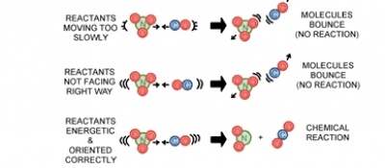

Factors that affect the rate of a reaction:
1. concentration – the higher the concentration the fast the rate of reaction will take place due to the increased number of combinations. For example, one molecule of chemical A and one molecule of chemical B can only interact with each other – (A₁B₁), but two molecules of chemical A and two molecules of chemical B increases the number of combinations to 4 (A₁B₁; A₁B_{2;} A₂B_{1;} A₂B₁)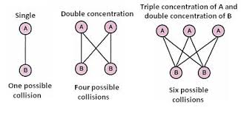
2. temperature – an increase in temperature increases the average kinetic energy of the particles in a substance; this can result in a greater number of effective collisions when the substance is allowed to react with another substance. If the number of effective collisions increase, the reaction rate will increase. To be effective, the energy of the collisions must be equal to or greater than the activation energy. Thus, a rise in temperature produces an increase in collision energy as well as in collision frequency.
3. surface area – the larger the surface area the greater number of particles exposed to the other reactant, thus more collisions occurs and therefore the rate of reaction increases. Catalytic converters use metals like platinum, palladium and rhodium to convert poisonous compounds in vehicle exhausts into less harmful things. For example, a reaction which removes both carbon monoxide and an oxide of nitrogen is:
Because the exhaust gases are only in contact with the catalyst for a very short time, the reactions have to be very fast. The extremely expensive metals used as the catalyst are coated as a very thin layer onto a ceramic honeycomb structure to maximize the surface area.

4. catalyst – a substance that changes the rate of a chemical reaction without itself being permanently consumed. The action of a catalyst is called catalysis. A biological catalyst is known as an enzyme.
5. nature of the reactants – some substances react more vigorously than others.

