Unit 1B Electronic Structure Review Worksheet
- Calculate frequency and wavelength using the speed of light formula. Calculate energy using Planck’s equation.
Complete attached worksheet

- Describe Niels Bohr’s experiment, discovery and atomic model:

- Describe the modern electron cloud quantum model:

- Draw an s orbital:

- Draw a p orbital:

- Draw a d orbital:

- Write the electron configuration for copper:

- Write the noble gas (abbreviated) electron configuration for iodine:

- 1s²2s²2p⁶3s²3p⁶4s²3d⁸ is the electron configuration for what element?

- [He]2s²2p³ is the noble gas (abbreviated) electron configuration for what element?

- Place the following types of electromagnetic radiation in order of largest wavelength to smallest: red, infrared, orange, radio and tv, violet, x-rays, green, ultraviolet, yellow, gamma, blue, microwave, indigo.
- Place the following types of electromagnetic radiation in order of largest frequency to smallest: red, infrared, orange, radio and tv, violet, x-rays, green, ultraviolet, yellow, gamma, blue, microwave, indigo.

- The aufbau principle states:

- Hund’s rule states:

- The Pauli principle states:

- Draw the orbital diagram for magnesium:

- Is this orbital diagram valid?

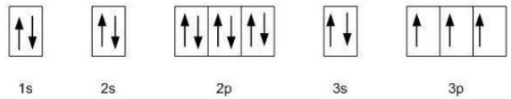

- If not, which principle/rule does it violate?

- If so, which element does it represent?

