Read This!
A phase is any part of a system that which all physical properties of a material are uniform. A state of matter is one of the distinct forms that matter takes on. There are four observable states of matter in everyday life: solid, liquid, gas and plasma. Plasma, which is ionized gas, is actually the most common visible state of matter in the universe as the stars are composed of plasma. On earth, every time you see a lightning bolt you are seeing plasma. Historically, the distinction is made based on qualitative differences in the properties of volume and shape. A solid has a fixed volume and a fixed shape; A liquid has a fixed volume and a variable shape; A gas has both a variable volume and a variable shape.

Model 1 – Phase Diagram for Carbon Dioxide
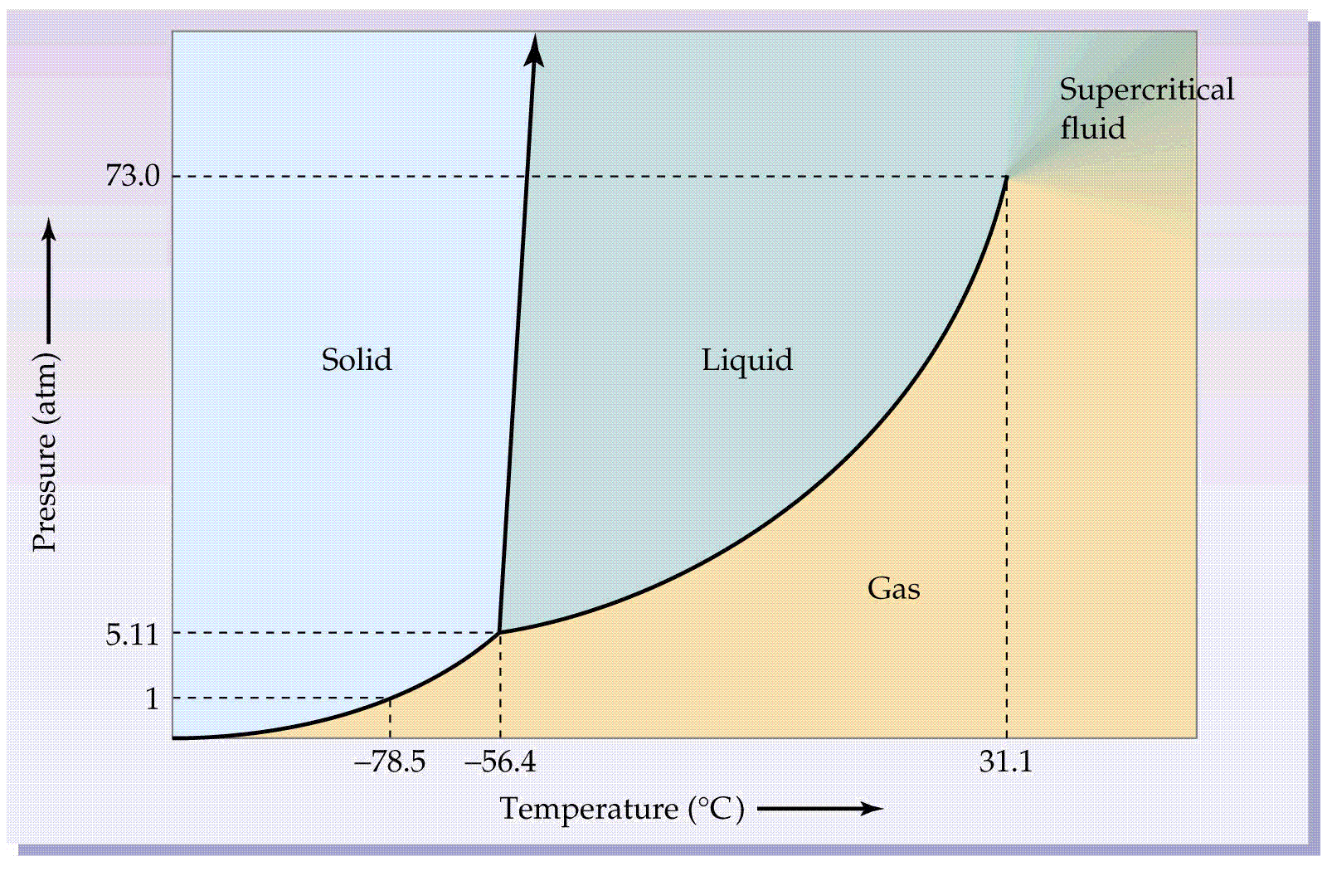
1. a. Model 1 is a Phase Diagram for what compound?

b. What is the formula for this compound?

2. Name the x-axis and y-axis in Model 1.

3. In what units are these two variables measured on Model 1?

4. a. Are the two axes equidistant (equally spaced) on Model 1?

b. Explain why or why not.

5. Name the three states of matter separated by solid lines on Model 1.

6. On Model 1, what do the three solid lines represent?

7. Trace over the solid line separating Solid / Gas in red. Trace over the solid line separating Liquid / Gas in blue and trace over the solid line separating Solid / Liquid in green.
8. The process (change of state) of condensation occurs when a gas changes into a liquid. Draw and label a blue arrow across the solid line showing the direction of condensation. The process of evaporation occurs when a liquid changes into a gas. Draw and label a blue arrow across the solid line showing the direction of evaporation.
9. The process of freezing occurs when a liquid changes into a solid and the reverse process is melting. Draw and label green arrows showing these two phase changes.
10. The process of deposition occurs when a gas changes into solid and the reverse process is sublimation. Draw and label red arrows showing these two phase changes.
11. Circle on Model 1 where the three solid lines meet. What is this junction called?

12. What is the purpose of the dashed lines on Model 1?
13. Use Model 1 to determine what state of matter CO₂ is at -78.5C and 73.0 atm.

14. Use Model 1 to determine what state of matter CO₂ is at 0C and 70.0 atm.

15. Use Model 1 to determine what state of matter CO₂ is at 31.1C and 1 atm.

16. At a constant 10 atm, list all the states of matter and processes that CO₂ undergoes when heated from
-78.5C to 35C.

17. At a constant 1atm, list all the states of matter and processes that CO₂ undergoes when cooled from
30C to -100C.

18. At a constant -60C, list all the states of matter and processes that CO₂ undergoes when depressurized
from 6 atm to 0.25 atm.

19. At -55.4C, explain all the states of matter and processes (changes of state) that CO₂ undergoes when pressurized from 1 atm to 80 atm.

20. The normal boiling point of a substance occurs at the temperature in which that substance boils at 1 atm of pressure. The normal freezing point of a substance occurs at the temperature in at which that substance freezes at 1 atm. Examine Model 1 where 1 atm of pressure is on the solid line separating Solid / Gas. Suggest a name for this point.

Read This!
Allotropes are two or more forms of the same element in the same physical state (solid, liquid, or gas) that differ from each other in their physical, and sometimes chemical, properties. The most notable examples of allotropes are found in groups 14, 15, and 16 of the periodic table. Gaseous oxygen, for example, exists in three allotropic forms: monatomic oxygen (O), a diatomic molecule (O₂), and in a triatomic molecule known as ozone (O₃).
A striking example of differing physical properties among allotropes is the case of carbon. Solid carbon exists in two allotropic forms: diamond and graphite. Diamond is the hardest naturally occurring substance and has the highest melting point of any element. In contrast, graphite is a very soft material, the substance from which the "lead" in lead pencils is made.

Model 2 – Phase Diagram for Carbon

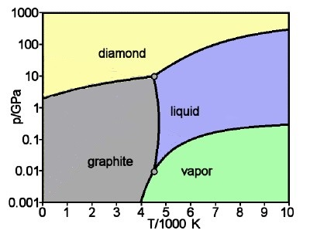

21. a. Model 2 is a Phase Diagram for what element?

b. What is the symbol for this element?

22. Name the x-axis and y-axis in Model 2.

23. a. In what units are these two variables measured on Model 2?

b. What do these symbols stand for?

24. a. Are the two axes equidistant (equally spaced) on Model 2?

b. Explain why or why not.

25. a. Compare Model 1 to Model 2. On Model 2, which section do you think corresponds to the “gas” section on Model 1?

b. Define this word.

26. On Model 2, the phase section of solid is divided into what sections?

27. a. Use Model 2 to determine what state of matter carbon is in at 3000K and 100GPa.

b. If solid, give specific allotrope.

28. a. Use Model 2 to determine what state of matter carbon is in at 3000K and 0.01GPa.

b. If solid, give specific allotrope.

29. a. Use Model 2 to determine what state of matter carbon is in at 8000K and 1GPa.

b. If solid, give specific allotrope.

30. a. Use Model 2 to determine what state of matter carbon is in at 9000K and 0.01GPa.

b. If solid, give specific allotrope.

31. At what pressure and temperature is the triple point for carbon?

32. At a constant 0.1GPa, list all the states of matter and processes that carbon undergoes when heated from 3000K to 10,000K.

33. At a constant 0.002GPa, list all the states of matter and processes that carbon undergoes when cooled from 5000K to 2000K.

34. At a constant 4100K, list all the states of matter and processes that carbon undergoes when depressurized from 0.1GPa to 0.001GPa?

35. At a constant 7500K, list all the states of matter and processes that carbon undergoes when pressurized from 0.01GPa to 100GPa?

Extra Credit
38. Using Model 2, describe carbon at the point of 4.5K and 10 GPa.

